



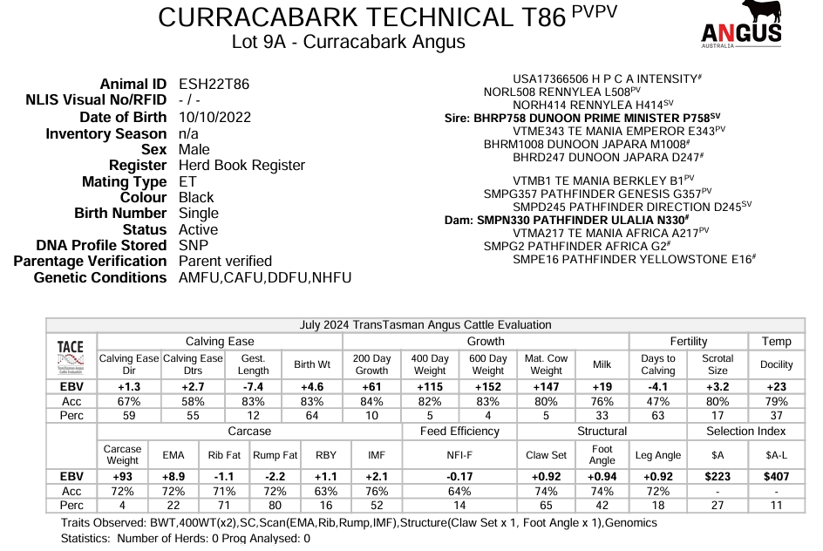**Note**: A younger E.T calf that earns his place in the first pen due to good growth and length. Brings a very balanced data set. High CE to high growth combination is good for  profits and good carcass data rounds him out. Brother to lot 10 and 27.

Note:** An attractive deep soft quiet bull with good CE to growth and positive fat reflecting his constitution. **Dual purpose heifer/cow bull.**

Note:** Very robust bull with extra length and excellent muscle on the spine that shows in his top 5% EMA data. **Dual purpose heifer/cow bull**