Lot | Age  Months | Identification | Weight  8/7/21 | Scrotal  7/6/21 | Suitable for Heifers
Angus
1 | 23 | Q38 | 814 | 39
2 | 22.5 | Q46 | 780 | 37
3 | 23 | Q34 | 850 | 40
4 | 22.5 | Q53 | 790 | 36 | ✓
5 | 24.3 | Q28 | 840 | 39
6 | 22 | Q48 | 776 | 37 | ✓
7 | 22 | Q51 | 750 | 38 | ✓
8 | 22.5 | Q43 | 790 | 44
9 | 21.5 | Q65 | 798 | 39
10 | 21 | Q77 | 838 | 37 | ✓
11 | 23 | Q31 | 814 | 40 | ✓
12 | 23 | Q29 | 782 | 36 | ✓
13 |  | WITHDRAWN | -
14 | 22 | Q54 | 718 | 38
15 | 20.5 | Q97 | 772 | 37
16 | 21 | Q78 | 796 | 40
17 | 21.5 | Q69 | 738 | 38
18 | 22 | Q55 | 758 | 37
19 | 21.5 | Q67 | 744 | 38
20 | 20 | Q91 | 766 | 44
21 | 22 | Q56 | 738 | 35
22 | 17 | R2 | 630 | 38
23 | 16 | R8 | 588 | 39 | ✓
24 | 15 | R20 | 520 | 38
25 | 15 | R21 | 542 | 39
26 | 16 | R9 | 576 | 34 | ✓
27 | 15.5 | R18 | 544 | 39
28 | 23 | Q41 | 736 | 38
29 | 23 | Q40 | 722 | 37
30 | 21 | Q80 | 740 | 38 | ✓
31 | 22 | Q58 | 704 | 36
32 | 22.5 | Q59 | 746 | 39 | ✓
33 | 22 | Q52 | 782 | 38
34 | 21 | Q73 | 738 | 37
35 | 22.5 | Q39 | 702 | 37
36 | 23 | Q35 | 750 | 36 | ✓
37 | 20 | Q98 | 748 | 40
38 | 22.5 | Q50 | 674 | 37 | ✓
Herefords
39 | 20.5 | Q165 | 828 | 41
40 | 22 | Q139 | 736 | 37
41 | 21.5 | Q147 | 732 | 38
42 | 21.5 | Q167 | 750 | 39
43 | 22 | Q130 | 742 | 40 | Homozygous poll
44 | 21 | Q150 | 740 | 41
45 | 24.5 | Q179 | 856 | 39
46 | 21.5 | Q140 | 800 | 37
47 | 20.5 | Q166 | 676 | 41
48 | 22.5 | Q120 | 792 | 35
49 | 21 | Q157 | 732 | 37
50 | 22 | Q108 by CRKN008 | 678 | 38 | Homozygous poll
51 | 22.5 | Q124 | 662 | 35 | ✓
51A | 22 | Q132 | 722 | 36
52 | 16.25 | R210 | 630 | 35
53 | 16.3 | R208 | 570 | 39
54 | 16.3 | R212 | 590 | 35
55 |  | WITHDRAWN

LOT 2 and 3:
VENDORS RETAIN THE RIGHT TO COLLECT SEMEN FOR IN HERD USE ONLY, AT VENDOR’S EXPENSE AND AT PURCHASER’S CONVENIENCE

Lot 10‘s Dam, ESHK4, is from Belle Vue B170 as below
Landfall Theo X39 TFAX39
Belle Vue B170 TIAB170
Te Mania Wargoona Z403 VTMZ403

LOT 39 CURRACABARK QUEST Q165 (H)
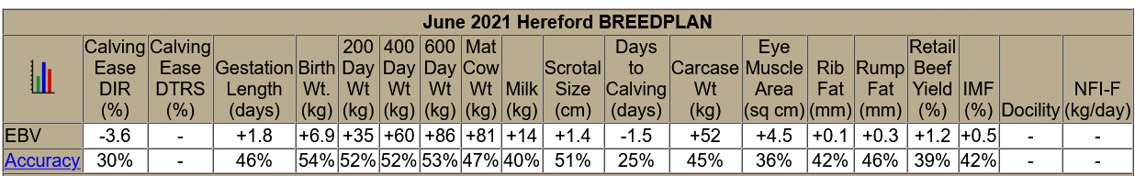
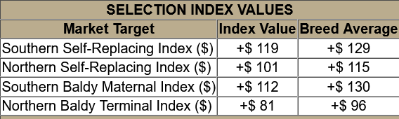

LOT 51A CURRACABARK QUAKKA Q132 (H) Tattoo Q132
Herdbook Registered Rego No. CRKQ132 Born 8/9/2019
SIRE: Talbalba Advance K134
DAM: Curracabark Favourite J122 x Yarram Park Unique F181
Thick, well made, soft and massive ema, all typical of T. Advance K134. Good bull.
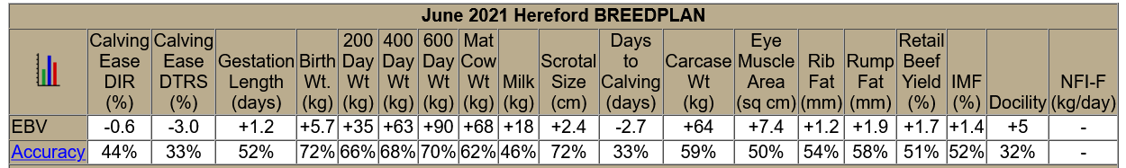
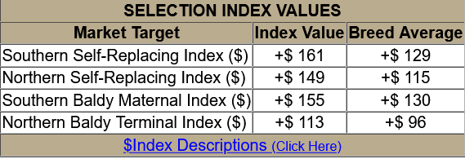
LOT 52 CURRACABARK REX R210 (S)
Herdbook Registered Rego No. CRKR210 Born 29/2/2020

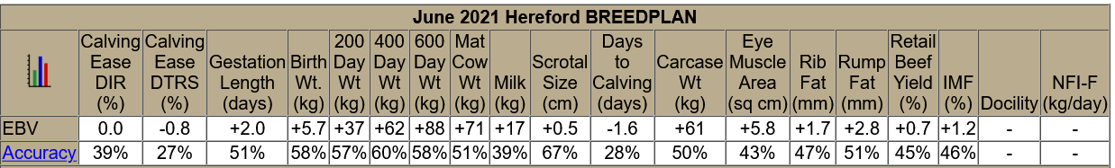
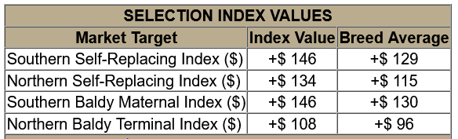

LOT 54 CURRACABARK RAMJET R212 (AI) (P)
